**Class Assignment (Main group elements)** 03/18/2021

Name: Max Shi

Name:

Name:

Name:

**Questions (20 pts):**

**Q1.** Which of the following metals will react **most violently** with water? (IE = Ionization energy)

Mg (IE = 738 kJ/mol)

Li (IE = 520 kJ/mol)

Na (IE = 496 kJ/mol)

K (IE = 419 kJ/mol)

Potassium will react most violently because it has the least ionization energy.

**Q2.** Write the reaction of potassium with water.

$${2 K}_{(s)}+{2 H}_{2}O_{(l)}→2 KOH_{(aq)}+2 {H_{2}}_{(g)}$$

**Q3.** Which of the following is the structure of 18-Crown-6.

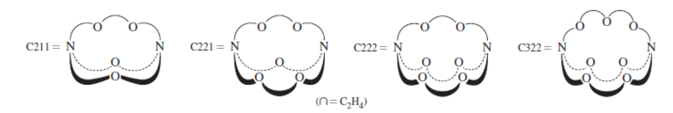 

18-crown-6 is the structure on the very right, the fourth structure.

**Q4.** List two uses of Crown-ether?

Crown ether is used as a phase transfer catalyst to increase solubility of inorganic compounds in organic solvents and is used to recognize and separate metal ions.

**Q5.** Label the following Cryptand C……..



C322

**Q6.** Which alkali metal will be bound strongly by Cryptand C221



C221 will bind most strongly to sodium because their radius’ are the most closely matched, and sodium is small enough to fit in the cavity radius.